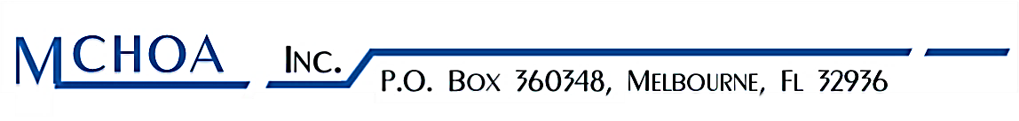

November 5, 2018
Dear Homeowners,

Regarding: 2019 Board of Directors Campaign

Operating a Homeowner’s Association carries with it many of the very same duties and responsibilities as any other business. Serving as a board member is a valuable and rewarding experience that should be undertaken by those who see it as an opportunity to serve their fellow neighbors while protecting and enhancing their assets in the community. It is a serious business, but can also be a worthwhile task, in order to safeguard the investments of all members.

I have had the honor of serving as your President and it was a truly rewarding experience. This past year, we have accomplished a lot, but there is always more to do.

The association has responsibilities of maintaining its common areas as well as the management and operation of the association’s business affairs in accordance with the standards established by the governing documents (By-Laws and DC&R). To the extent that an association (a non-profit corporation) has such authority and control, it is the Board of Directors that carries out these duties and responsibilities.

The current members on the Board will all be stepping down as of December 31, 2018. It’s now time to think about filling the five (5) opening positions for the 2019 Board of Directors. Your participation is crucial! If you wish to have your name included on the ballot, please complete the attached form. Also find in this packet, the options to submitting your nomination on line. Please make sure it is received by the Association on or before by November 30th, 2018 before 5:00 P.M. The Election will be held at the Annual Meeting on January 14, 2019.

The Board will appoint a committee prior to the election. The purpose and duties of the election committee include receiving and tabulating the ballots. New Board Members will conduct the annual meeting in January 2019. Contact us if you are available for a few hours to be on the committee.

I have worked aggressively to prevent our HOA from the consequences of losing receivership which would leave the HOA owners powerless. Failure to fill the five (5) positions on the Board of Directors (according to The 2018 Florida Statues 720) will result in turning our receivership over to the circuit courts to have a legal firm manage the Meadow Cove HOA. Of course, taking this action is the last resort, since lawyers do not work for free, and it is usually expensive and divisive for home owners. Our annual assessments would increase more than 5x’s the amount it is now. Please consider volunteering a little of your time next year for the betterment of your community.

Best Regards,

Rhoda Phillips
President
Meadow Cove Homeowners’ Association

